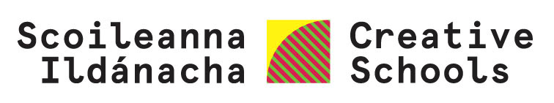

Your Creative Schools Plan
Developing your school plan

School:
Roll no:
ARN:

Your Creative Schools Plan:

- Ensures children/young people participate in developing, implementing and evaluating the plan.
- Strengthens or develops links between your school and artists and arts and cultural organisations locally and/or nationally.
- Connects to your School Improvement/DEIS plan.
- Connects to the Wellbeing Framework.
- Connects to Key skills in the curriculum.

There are two sections to complete:

- Part 1: Your Creative School Plan
- Part 2: Your Activity Plan(s) for this school year

Use the Understand document you created last year to help you develop your Plan.

Part 1: Your Creative Schools Plan
Complete this section in cooperation with the relevant school teams, e.g. Leading Learning Team, SIP, DEIS team etc. Your Creative Associate can also support you with this section.
  - Creative Schools – School Self Evaluation
Some areas of focus for your Creative School journey are named in the row below:
Foster a culture of youth voice |  | Enhanced arts  & creativity |  |  | Greater inclusion |  |  | Improved teaching  & learning |  |  | Improved wellbeing |  |  |  | Other/s of your choice
Select one of your school’s existing SIP/DEIS targets and describe how it links to your Creative Schools journey area(s) of focus
  - Children and Young People’s participation in decision making
Some methodologies for developing young people’s participation in decision
making through creative consultation are named in the row below:
Creative workshops/  taster sessions |  |  |  | Staff/student committee/team |  | Surveys |  |  |  | Ballots/Votes |  |  |  | Other/s of your choice
Tell us about some of the methodologies you are using and outline how that looks in your school/centre
  - What key competencies/skills are your students developing
through their engagement with Creative Schools?
  - Documenting, reflecting, assessing and evaluation.
Some of the methodologies you may already be using are named in the row below:
Visual diaries | Recordings |  | Noticeboards |  | Film |  | Exhibition |  | Festival |  |  | Performance | Surveys |  |  | Other/s of your choice
Tell us about how your school is capturing the learning and the voices of young people throughout your Creative Schools journey.

Part 2: Your Activity Plan(s) for this school year
2.1 Actions that your school/centre has agreed for your Creative Schools plan, e.g. Dance: CPD for teachers developing their confidence in using dance across curriculum areas. (You can add more lines if you need them.)
Area of arts/creative practice | Action outline

Part 2. Action Plan(s) for each activity
2.2 This section is designed to support your project management of the actions outlined above
Copy and paste this template box for each action.
Area(s) of arts/creative practice
Timeframe | Planned start date: | Planned completion date:
Who will participate? | Classes/year groups: | No. of students involved:
Key skills that will be developed through this activity?
Which artists, creative practitioners, arts, and cultural organisations are involved? | Name of artist/cultural organisation: | Contact details:
What outputs, if any, do you expect from this activity?
Exhibition, performance, broadcast, workshop, peer teaching, other
When and how will this activity be evaluated?

